Commands to initialize package.json

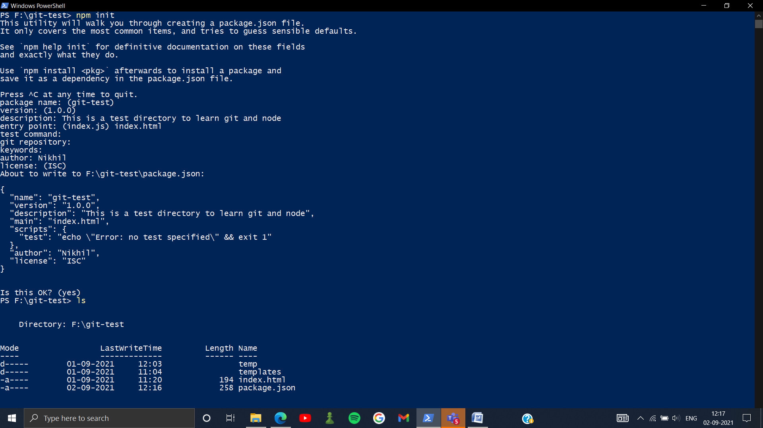

At git repository you can add link of any git repository